**Acceptance Conformity for Radar X Sensor Test Equipment**

**Applicable for Radar 5 Sensor Test Equipment**

**with 77 G1.3 Corner Fixture**

EPT-RDR05G1.3-01-01/EPT-RDR05G1.3-01-02

**RESTRICTED ACCESS**

DISTRIBUTION :

Firm Recipient Copies

CFM Jason Cai 1

CFM Cecilia Xia 1

CFM Daniel Wang 1

CFM Steven Wu 1

**REVISION**

Revision Date Author Comments

A 2022-11-29 Jason Cai Initial Release

**CONTENTS**

1. REFERENCE 4

2. OBjective 4

3. Method of measurement 5

4. List of the ACCEPTANCE CRITERIA for SENSOR TEST EQUIPMENT 5

5. Conclusion 5

# REFERENCE

**Trial date :** 2022/11/29

**Trial done by :** Jason Cai

**Line** : Radar 5

**Station:** Sensor Test

**Software:** Labwindows CVI, Teststand,

# OBjective

Verify the conformity of the Radar 5 Sensor Test with the production requirements and validate it can be used for production.

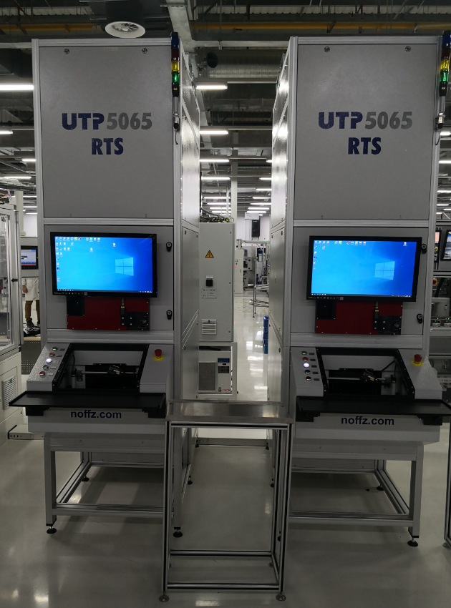

# Method of measurement

The acceptance criteria has been defined and listed for the Sensor Test equipment and the system will be verified to meet the acceptance criteria.

# List of the ACCEPTANCE CRITERIA for SENSOR TEST EQUIPMENT

See the attached file.

***List of the Acceptance Criteria for Radar 5 Sensor Test.***



# Conclusion

Radar 5 Sensor Test equipment is conformed to meet the acceptance criteria and production requirements.